**Projector Screen**

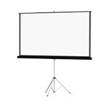

**Specifications:**

**DC-21 Document Camera Epson**

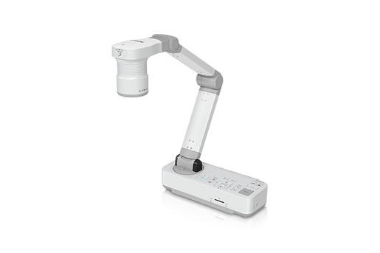

**Specifications:**

**Input Terminal:**

* HDMI
* Computer In (VGA)
* Display Out (VGA)
* USB-B (for connection to PC/Mac®)
* SD Card Slot1

**Driver:**

* TWAIN (for Windows)

**Functions:**

* Rotation, Zoom (+, -, selectable, x1)
* Auto Focus
* Freeze, Record
* Time-lapse
* Picture Control (Brightness, Contrast, White Balance, Auto White Balance)

**Saving Format:**

* Still Image: JPG, BMP, PNG
* Video (Windows): AVI
* Video (Mac): MOV
* Other: PDF, EIT

**Operating Systems:**

* Windows 7
* Windows 8
* Windows 10
* Windows Vista
* Mac OS X 10.7.x, 10.8.x, 10.9.x, 10.10.x, 10.11.x

**Temperature:**

* 41 ° to 95 °F (5 ° to 35 °C)

**Weight:**

* 5.8 lb

**Power Supply Voltage:**

* 100 - 240 V AC

**Rated Frequency:**

* 50/60 Hz

**Power Consumption:**

* 13 W (Operating)  
  < 0.5 W (Standby Mode)

**Output Voltage of AC Power Adapter:**

* DC 12 V

**Powerlite 1795F Wireless full HD 1080 3lcd projector epson**

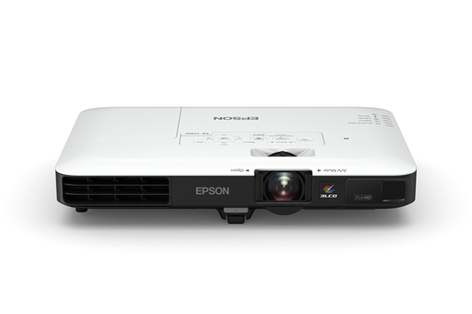

**Specifications:**

**Projection Method:**

* Front/rear ceiling mount
* Front/rear desktop

**Pixel Number:**

* 2,073,600 dots (1920 x 1080) x 3

**Aspect Ratio:**

* 16:9

**Native Resolution:**

* 1920 x 1080 (1080p)

**Resize:**

* 640 x 480 (VGA)
* 800 x 600 (SVGA)
* 1024 x 768 (XGA)
* 1280 x 800 (WXGA)
* 1280 x 1024 (SXGA)
* 1400 x 1050 (SXGA+)
* 1440 x 900 (WXGA+)
* 1680 x 1050 (WSXGA+)
* 1600 x 1200 (UXGA)
* 1920 x 1200 (WUXGA)

**Lamp Life:**

* 7,000 hours (ECO Mode)
* 4,000 hours (Normal Mode)

**Size - projected distance:**

* 30" to 300" (2.2 to 27.2 ft)

**Keystone Correction:**

* Automatic Vertical: ± 30 degrees
* Automatic Horizontal: ± 20 degrees

**Contrast Ratio:**

* Up to 10,000:1

**Color Reproduction:**

* Up to 1.07 billion colors

**Weight:**

* 4.0 lb

**Operating Temperature:**

* 41 ° to 95 °F (5 ° to 35 °C)

**Type:**

* Optical Zoom (Manual)
* Focus (Powered)

**Focal Length:**

* 14.06 – 16.82 mm

**Zoom Ratio:**

* Optical zoom 1.0 – 1.2

**Display Performance:**

* NTSC: 480 line
* PAL: 576 line

**Input Signal:**

* NTSC
* NTSC4.43
* PAL
* M-PAL
* N-PAL
* PAL60
* SECAM SDTV
* HDTV

**Interfaces:**

* 1x HDMI (Supports MHL® connectivity)
* Computer/component video: 1x D-sub 15 pin
* Composite video: 1x RCA
* USB Type A: 1x PC-free USB and other
* USB Type B: 1x USB Plug ‘n Play

**Audio Output:**

* 1 W mono speaker

**Features:**

* Power
* Source Search Selection
* Computer
* Video
* A/V Mute
* Freeze
* User ID
* Auto
* Aspect
* Color Mode
* NUM
* Page Up and Down
* E-zoom
* Volume
* Help
* Menu
* Enter
* ESC and Pointer functions

**Operating Distance:**

* 19.7 ft

**Operating Angle:**

* Right/left: Front: ± 60 degrees; rear: ± 30 degrees
* Upper/lower: Front: ± 30 degrees; rear: ± 30 degrees

**Power Supply Voltage:**

* 100 – 240 V ±10%, 50/60 Hz

**Power Consumption:**

* 309 W (Normal Mode), 217 W (ECO Mode)

**EX3240 SVGA 3lCD projector epson**

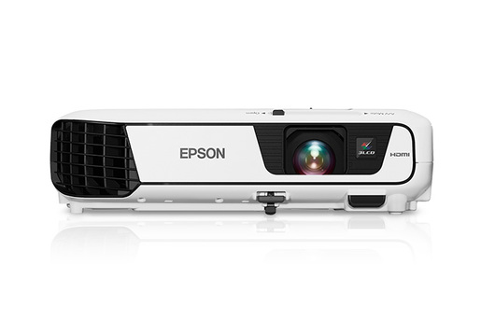

**Specifications:**

**Projection System:**

* Epson 3LCD
* 3-chip technology

**Projection Method:**

* Front / rear / ceiling mount

**Pixel Number:**

* 480,000 dots (800 x 600) x 3

**Aspect Ratio:**

* 4:3

**Native Resolution:**

* 800 x 600 (SVGA)

**Resize:**

* 1024 x 768 (XGA)
* 1152 x 864 (SXGA)
* 1280 x 800 (WXGA)
* 1280 x 960 (SXGA2)
* 1280 x 1024 (SXGA3)
* 1440 x 900 (WXGA+)
* 1400 x 1050 (SXGA+)

**Lamp Life:**

* ECO mode: Up to 10000 hours
* Normal mode: Up to 5000 hours

**Throw Ratio Range:**

* 1.45 (Zoom: Wide)
* 1.96 (Zoom: Tele)

**Size - projected distance:**

* 30" – 350" (0.88 – 10.44 m)

**Keystone Correction:**

* Automatic: Vertical: ±30 degrees
* Manual: Horizontal: ±30 degrees (Easy-Slide Horizontal Image Correction)

**USB Plug 'n Play:**

* Projects audio and video
* PC and Mac compatible

**Contrast Ratio:**

* Up to 15,000:1

**Color Reproduction:**

* Up to 1.07 billion colors

**Temperature:**

* 41° to 95° F (5° to 35° C)

**Weight:**

* 5.29 lb

**Security:**

* Kensington-style lock provision
* Password protect function

**Type:**

* Digital zoom (Manual)/Focus (Manual)

**F-number:**

* 1.44

**Focal Length:**

* 16.7 mm

**Zoom Ratio:**

* Digital zoom 1.0 – 1.35

**Display Performance:**

* NTSC: 480 lines
* PAL: 576 lines

**Interfaces:**

* HDMI x 1
* Computer / Component video: D-sub 15 pin x 1

**S-video:**

* Mini DIN x 1

**Composite video:**

* RCA (Yellow) x 1

**Audio in:**

* RCA x 1 (White / Red)

**USB connector:**

* Type A x 1 (PC-free USBand other, Wireless LAN)

**USB connector:**

* Type B x 1 (USB Plug 'n Play)

**Speaker:**

* 2 W (mono)

**Including feet:**

* 11.7" x 9.2" x 3.2" (W x D x H)

**Excluding feet:**

* 11.7" x 9.2" x 3.0" (W x D x H)

**Features:**

* Source search selection
* Power
* Volume
* e-zoom
* A/V Mute
* Freeze
* Menu
* page up and down,
* help
* auto
* mouse functions

**Operating Distance:**

* 19.7 ft (6 m)

**Operating Angle:**

* Right / Left: ±30 degrees
* Upper / Lower: ±15 degrees

**Power Supply Voltage:**

* 100 – 240 V ±10%, 50/60 Hz

**Power Consumption:**

* ECO mode: 214 W
* Normal mode: 291 W